#7 Report a Crime or Emergency
Board Game Instructions

Materials:
- Board Game (page 2), game pieces (small squares of colored paper, coins, colored magnets, or any other tidbit that students can move around the game board)
- A designated quarter in lieu of a dice (with heads = move 1 square and tails = move 2 squares or vice-versa)
- Treats (i.e. mini chocolates, pencils, homework pass) of your choice to give to the student from each group who first lands on the ending star.

Directions:

1. Make copies of the game board. You will need one game board for each group of three to four students in your class. You may want to print the games on card stock and/or insert games into a plastic sheet protector.

2. Place students into groups of 3 or 4 and give each group a game board. Give each student a game piece. Move your finger over the game board to show students the direction they will move their pieces (i.e. from the “Start here” box to the “Great job!” box.) Tell your students to toss the designated quarter and move their pieces 1 or 2 spaces depending on whether the quarter lands on heads or tails.

3. Give students time to play. (Some squares have the same health problem or phone call prompt. This is to provide extra practice.)

Note to the teacher: Students need to identify the problem if they land in a picture square. If they land on text, they are to respond appropriately to the text, not read it. (i.e. If the square asks, “What’s your telephone number?” the student should respond, “788-4646.”)

Start here. | Spell your last name, please. |  | 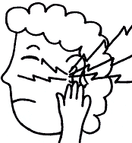 |  | 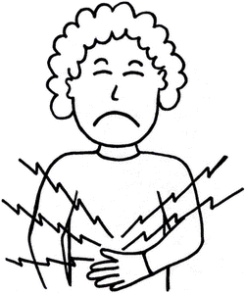
 |  |  |  |  | What’s the problem?
 |  |  | What’s your telephone number? |  | 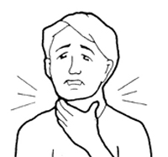
Hello. Dr. Brown’s office.
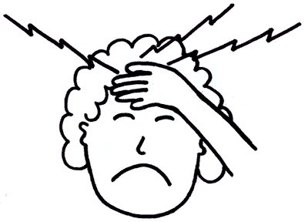 |  |  | Hello. San Diego Family clinic. Miss Wilson speaking. |  | 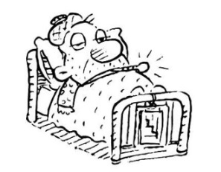
 |  |  |  |  | What’s your telephone number?
Spell your last name, please. |  |  | 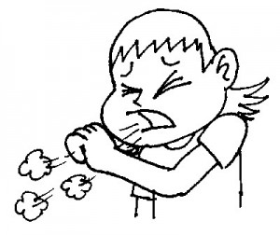 |  | The doctor can see you at 10:00 on Thursday.
What’s the problem?
 |  |  |  |  | End….Great job!

